**Experiment-9**

**Data Link Layer Traffic Simulation using Packet Tracer Analysis of CSMA/CD& CSMA/CA**

**Step1:** 1 Hub and 6 PCs

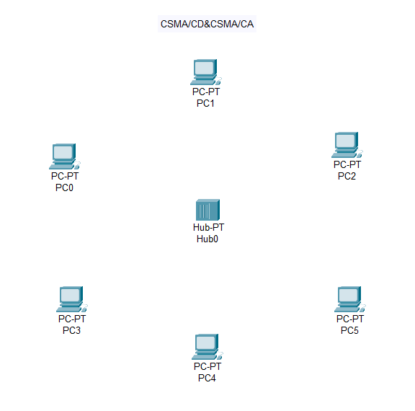

**Step2:** connect fast ethernets from Hub to PCs

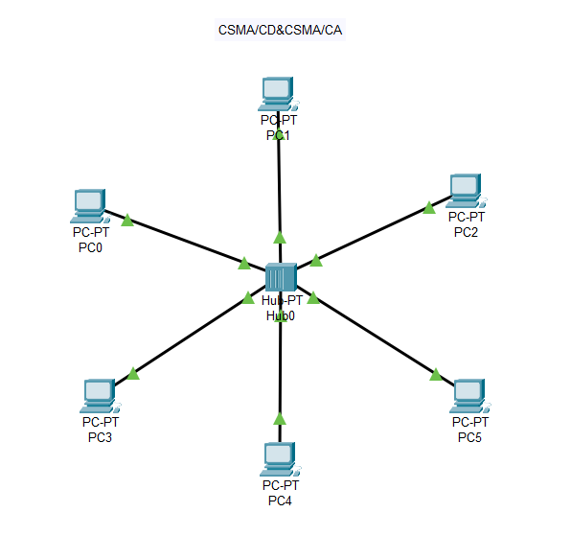

**Step3:** Assign IP address for each PCs

IP address for PC0:192.168.0.1

IP address for PC1: 192.168.0.2

IP address for PC2: 192.168.0.3

IP address for PC3: 192.168.0.4

IP address for PC4: 192.168.0.5

IP address for PC5: 192.168.0.6

**Step4:** allocate the message

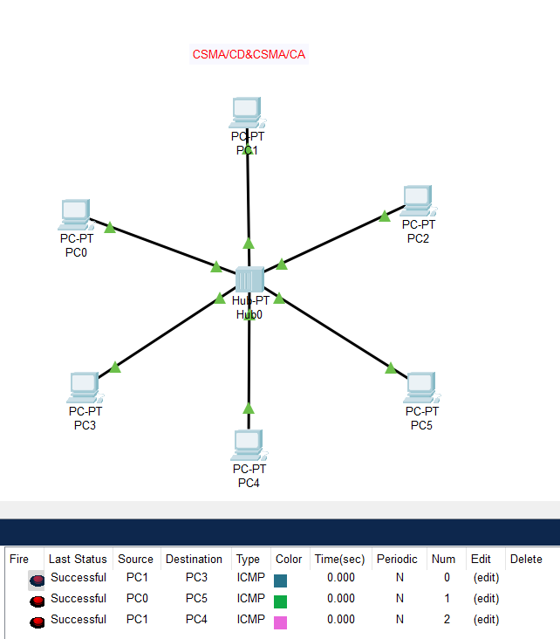

**Result:** message sent successfully from PC1-PC3